
FINAL PROJECT

Course title: Artificial Intelligence
Project title: Air Quality Prediction
Course code: CSE 422
Section: 14
Group: 07

Submitted by:
Arnab Das- 19301029
Meshkatul Arefin- 24341079

Department of Computer Science and Engineering

Date: 6th January 2025

Table of Contents
Introduction 3
Dataset Description 4
Data Pre-processing 8
Missing Value Treatment 8
Scaling 8
Split Train Test 9
ML Models Implementation 10
Comparison of Models 11
Confusion Matrices 12
Results & Analysis 15
Conclusion 18
References 19

Introduction

Carbon monoxide (CO) is a colorless, odorless gas. It reaches high levels when cars, factories, and burning fuels release emissions into the air. The U.S. Environmental Protection Agency (2022) explains that CO reduces the blood’s ability to carry oxygen. This can cause headaches, dizziness, and, in severe cases, death.

Forecasting CO levels is important because it helps protect public health and the environment. This project uses machine learning to predict CO levels by examining data on particulate matter, nitrogen oxides etc. Our aim is to provide an effective model for air quality prediction.

Dataset Description

The Air Quality UCI dataset contains 9,357 rows and 16 columns. Researchers collected this data with a gas sensor array in an urban area in Italy. Each row has measurements of pollutants and weather factors.

Key Columns

- CO_GT (mg/m³): Actual carbon monoxide levels.
- PT08_S1_CO: Sensor data for carbon monoxide.
- NMHC_GT (microg/m³): Actual non-methanic hydrocarbon levels.
- C6H6_GT (microg/m³): Actual benzene levels.
- PT08_S2_NMHC: Sensor data for non-methanic hydrocarbons.
- Nox_GT (ppb): Actual nitrogen oxide levels.
- PT08_S3_Nox: Sensor data for nitrogen oxides.
- NO2_GT (microg/m³): Actual nitrogen dioxide levels.
- PT08_S4_NO2: Sensor data for nitrogen dioxide.
- PT08_S5_O3: Sensor data for ozone.
- T (°C): Temperature.
- RH (%): Relative humidity.
- AH: Absolute humidity.

Source: Link
The project starts by viewing how each feature is distributed. We use histograms and violin plots to see if data is skewed or if outliers exist. Scatter plots then help us check how pollutants relate to factors like temperature and humidity. We also use line charts and area charts to track changes in pollutant levels over time. Next, we apply a correlation heatmap to reveal how each feature relates to the others, which aids feature selection and helps us detect multicollinearity.
These steps guide exploratory data analysis by revealing patterns, spotting outliers, and highlighting links among variables. This knowledge then informs modeling and prediction decisions.
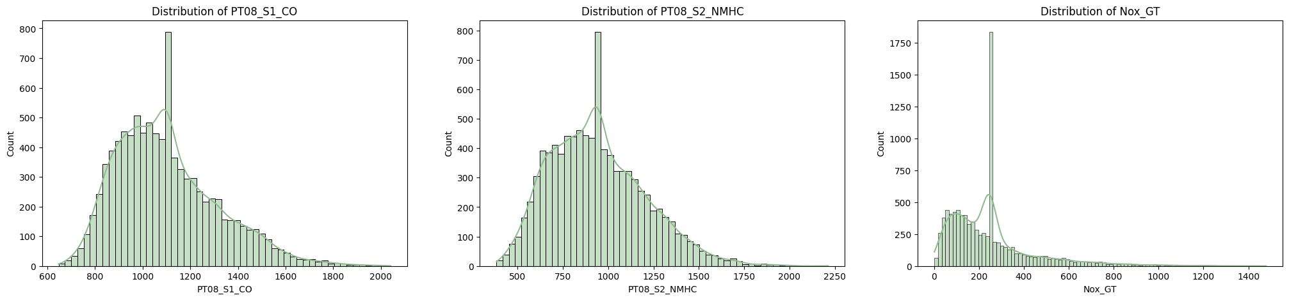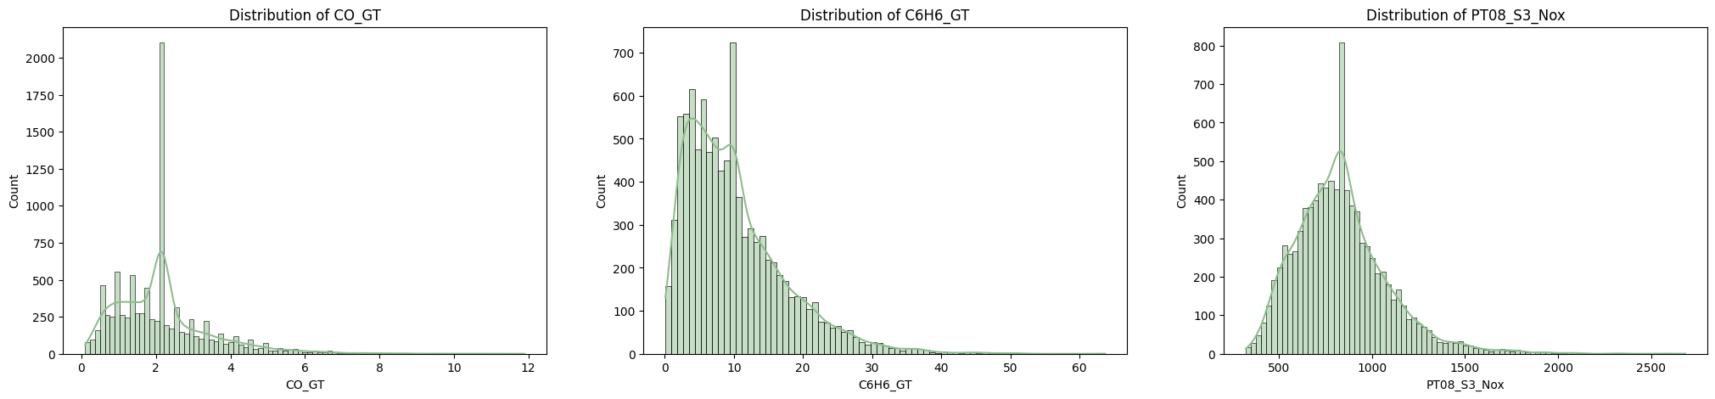
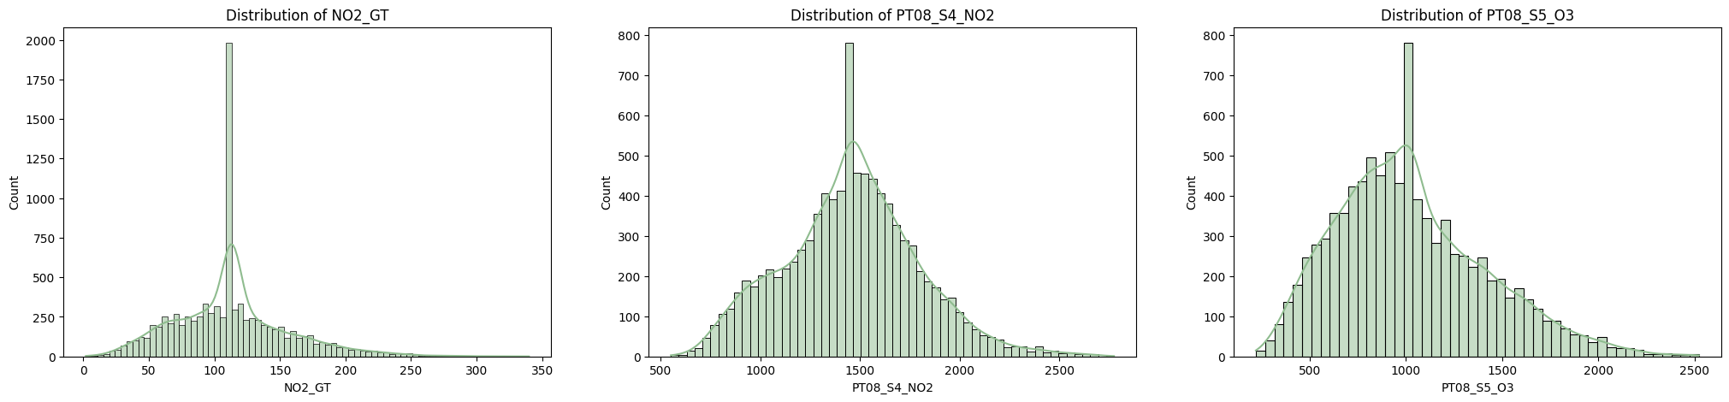
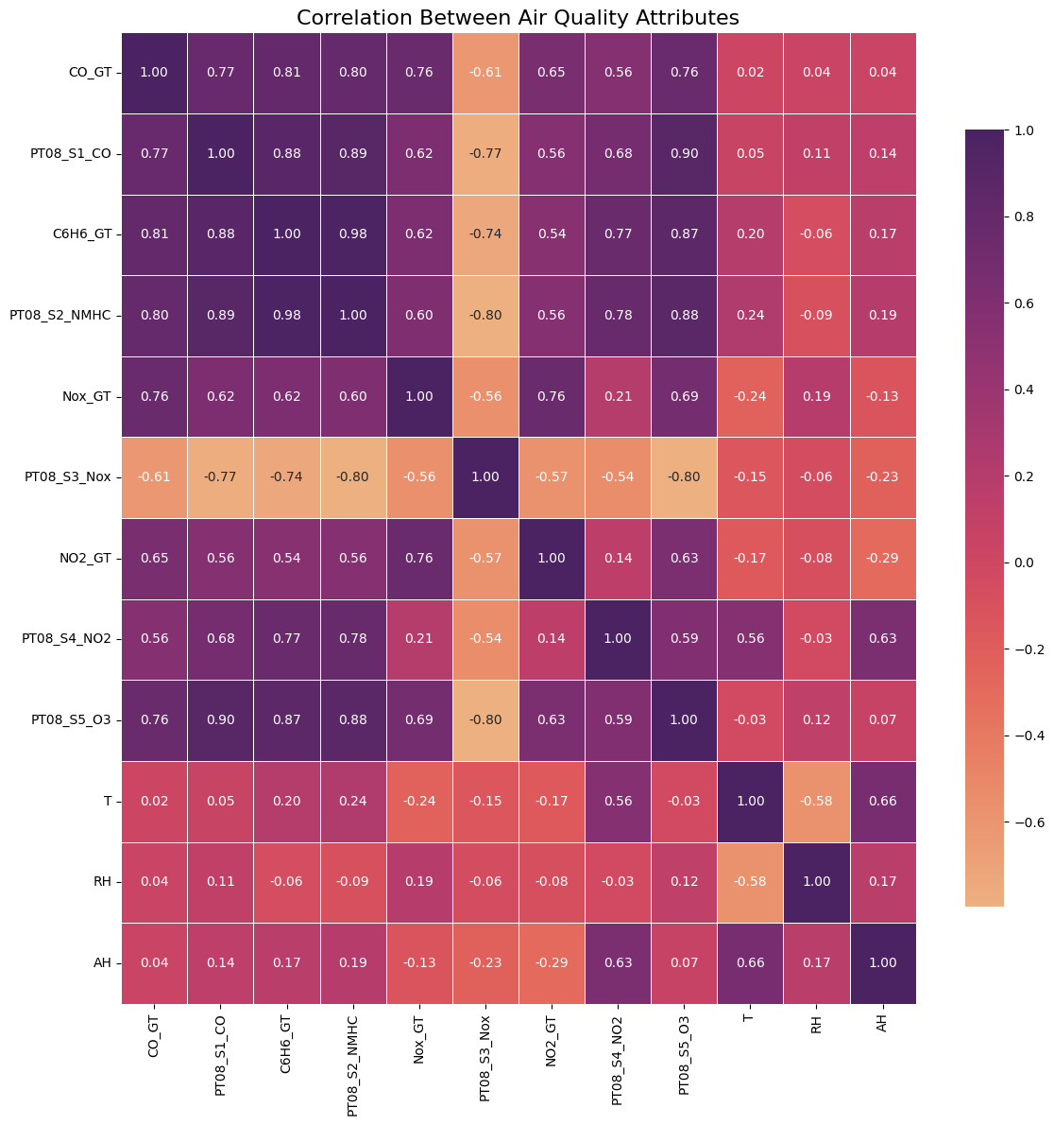

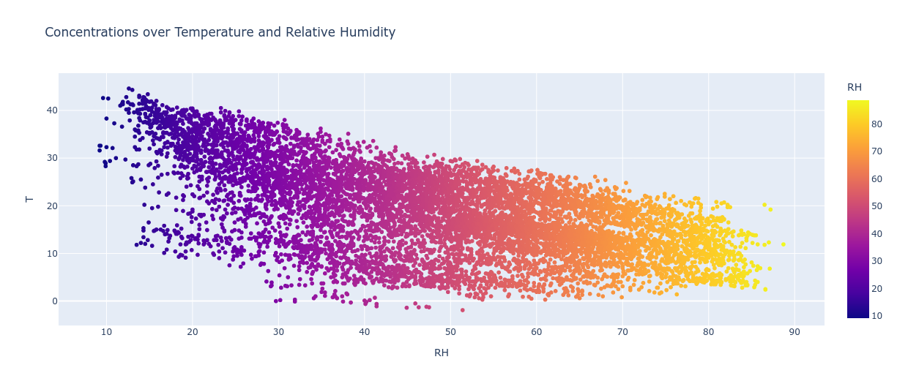

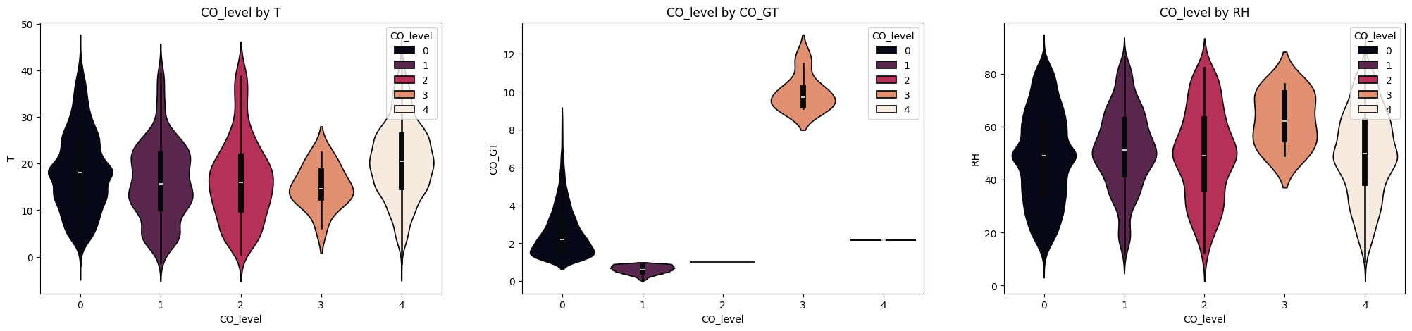

Data Pre-processing

The air quality data went through steps to handle missing values, remove outliers, and fix scaling issues.

Missing Value Treatment

- The dataset marked missing values with -200.
- One column (NMHC_GT) had 8,443 missing values out of 9,357. It was removed.
- In the remaining columns, -200 was replaced with NaN. Then we filled these NaN entries with the mean of each column.
- This filled in all missing points so no data remained empty.

Scaling

We scaled the data so features of different sizes would not overshadow one another. We picked the columns with more than 10 unique values. Then we applied MinMaxScaler from scikit-learn to move all values into a range from 0 to 1. After these steps, the dataset was ready for modeling.

Proper handling of missing values and scaling can improve the performance of machine learning models. Clean data often leads to better results.

Split Train Test

Then we splitted the sections for train and test. For training, we kept 70% of the data set and the rest 30% for the test. The variables that are used, which are mainly datasets for training and testing are given as follows:
● X_train
● X_test
● y_train
● y_test

ML Models Implementation

After data pre-processing, the project implemented several machine learning models to predict the CO level based on the other air quality attributes. The following models were trained and evaluated

1. Decision Tree Classifier

- Trained before and after scaling.
- Achieved a 1.0 train score and 1.0 test score in both cases.
- This suggests overfitting, as it performs perfectly on both training and testing data.

2. Random Forest Classifier

- Trained after scaling.
- Scored 1.0 on training, which may indicate overfitting.
- Achieved a 0.9968 test score, which shows strong generalization.

3. K-Nearest Neighbors (KNN)

- Used n_neighbors=3 after scaling.
- Reached 0.94 on training and 0.8857 on testing.
- Performed worse than the tree-based models on this dataset.

Comparison of Models

- We used bar plots to show train and test accuracies.
- Decision Tree and Random Forest both performed better than KNN.
- We measured precision and recall score for all three models.
- Decision Tree and Random Forest had perfect precision and recall on the training set, while KNN scored lower.
- On the test set, Decision Tree and Random Forest had higher precision and recall than KNN.

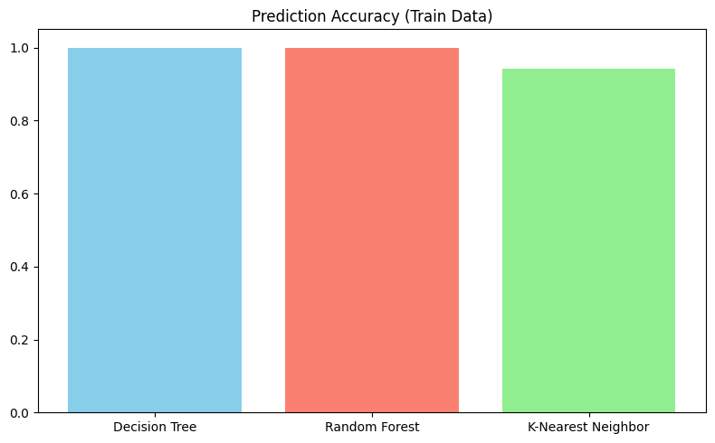

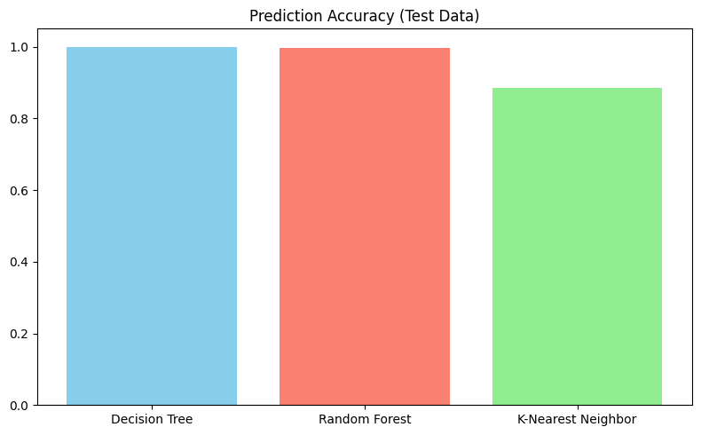

Confusion Matrices

- We plotted confusion matrices as heatmaps for each model on the test set.
- Decision Tree had very few misclassifications.
- Random Forest also showed minimal misclassifications, suggesting good performance.
- KNN had more off-diagonal entries, which indicates more misclassified points.

Overall, the tree-based models (Decision Tree and Random Forest) performed exceptionally well on this dataset, with the Random Forest model being the recommended choice as it showed good generalization performance without apparent overfitting issues.

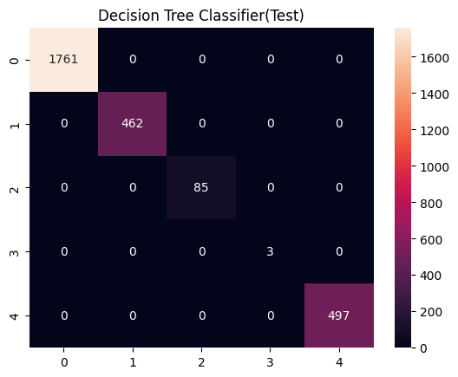

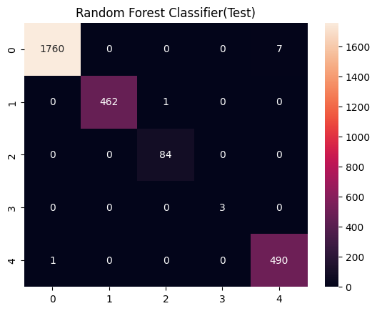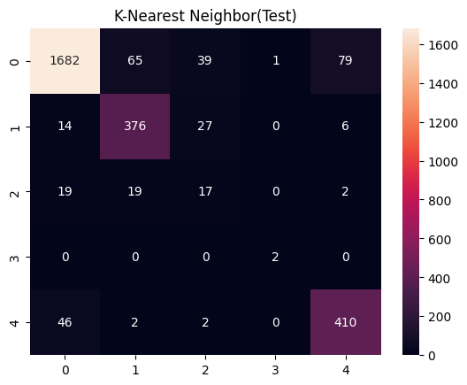

Results & Analysis

Our experiments showed that the Decision Tree and Random Forest classifiers both achieved high accuracy on the training and test data. The Decision Tree, however, had a perfect score on both sets, raising concerns about overfitting. Overfitting can happen when a model memorizes the training data rather than learning general patterns.

The Random Forest classifier performed well during tests. It reached an accuracy of 0.9968. It also showed a low risk of overfitting. Its precision and recall both measured 0.9968, which means it identified both positive and negative examples with few errors. These results make Random Forest a sound choice for this dataset.

K-Nearest Neighbors (KNN) did not match the tree-based models. Its accuracy, precision, and recall were lower on both the training and test sets. This suggests it did not capture the data’s structure as effectively as the other methods.

We plotted confusion matrices for each model on the test data. The Decision Tree and Random Forest had few off-diagonal entries, so they made fewer incorrect predictions. KNN, in contrast, had more off-diagonal entries, which led to a higher misclassification rate.

In summary, Random Forest showed the most balanced performance. The Decision Tree also produced high scores, but its perfect accuracy hinted at overfitting. KNN had lower scores. These results suggest that Random Forest is the best model for predicting CO levels in this air quality dataset.

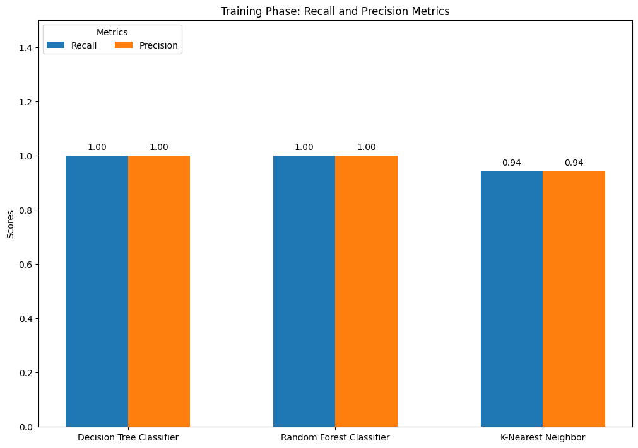

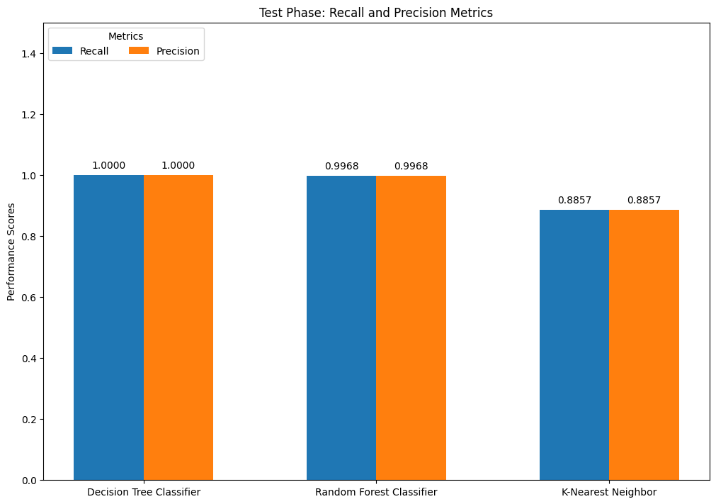

Conclusion

We trained machine learning models to predict CO levels from air quality data. We explored and cleaned the data and tested several models, including Decision Tree and Random Forest. Both models predicted CO with strong results. The Decision Tree delivered balanced outcomes, while the Random Forest showed higher recall but lower precision. These findings can help authorities keep air quality within safe limits and protect public health and the environment.

References

U.S. Environmental Protection Agency. (2022). Carbon monoxide (CO) pollution in outdoor air. [Website]. https://www.epa.gov/co-pollution

Dataset: Link

